Chapter 6 Study Guide on Sedimentary & Metamorphic Rocks

SECTION **6.1 *Formation of Sedimentary Rocks***

*Using your textbook, read about the processes that form sedimentary rocks. Use each of the terms below to complete the following statements.*

1. Consists of solid material that has been deposited on Earth's surface by wind, water, ice, gravity, or chemical precipitation.
   1. chemical weathering
   2. sediment
   3. unsorted deposits
2. Glaciers and landslides tend to create in which sediments of different sizes are mixed together.
   1. chemical weathering B) sediment C) unsorted deposits
3. During the minerals in a rock are dissolved or otherwise chemically changed,
   1. chemical weathering B) sediment C) unsorted deposits
4. The process by which mineral growth binds sediment grains together into solid rock is
   1. Cementation
   2. sedimentary rock
   3. elastic sediment
5. Weathering produces, which are rock and mineral fragments.
   1. Cementation B) sedimentary rock C) elastic sediment
6. When sediments become cemented together, they form
   1. Cementation B) sedimentary rock C) elastic sediment
7. As a result of sediments are laid down on the ground or on the bottom of bodies of water.
   1. sorted deposits
   2. lithification
   3. physical weathering
   4. deposition
8. The physical and chemical process transforms sediments into sedimentary rocks.
9. sorted deposits
10. lithification
11. physical weathering
12. deposition
13. During , minerals remain chemically unchanged) and rock fragments simply break off of the solid rock along fractures or grain boundaries.
14. sorted deposit
15. lithification
16. physical weathering
17. deposition
18. Sediments tend to form when transported by water and wind.
19. sorted deposit
20. lithification
21. physical weathering
22. deposition

# SECTION 6.1 Formation of Sedimentary Rocks, continued

Using your textbook, read about lithification. For each statement below, SELECT “TRUE = A” or “FALSE= B”

TRUE TRUE

TRUE

TRUE

TRUE TRUE

TRUE TRUE

FALSE FALSE

FALSE

FALSE

FALSE FALSE

FALSE FALSE

1. Lithification begins with erosion.
2. Muds may contain up to 60 percent water and shrink as excess water is squeezed out.
3. Sands are usually poorly compacted during deposition, and they tend to compact a great deal

during burial.

1. Groundwater, oil, and natural gas are commonly found within pore spaces in sedimentary rocks.
2. The temperature in Earth's crust decreases with depth.
3. Physical weathering changes the composition of mineral fragments,
4. In one type of cementation, a new mineral grows between sediment grains,
5. Mud compacts more than sand.

*In your textbook, read about the features of sedimentary rocks. Use each of the terms below to complete the passage.*

1. *cross-bedding*
2. *graded bedding*
3. *transport*
4. *bedding*

The primary feature of sedimentary rocks is (19) or horizontal layering. The type of bedding that occurs depends upon the sediment's method of (20) . Bedding is called

(21) when the heaviest and coarsest material is on the bottom. A second type of bedding called (22) forms as inclined layers of sediment migrate forward across a horizontal surface.

*Use each of the terms below to complete the passage*

* 1. *Lithification*
  2. *ripple marks*
  3. *fossils*
  4. *sand dunes*

Large-scale cross-bedding can be formed by migrating (23) . When sediment is moved into small ridges by wind or wave action, (24) can form. Many sediment rocks contain (25) , the preserved remains, impressions, or any other evidence of once-living organisms. During (26) , parts of an organism can be replaced by minerals and turned into rock.

**Section** **6.2 *Types of Sedimentary Rocks***

*Using your notes & textbook, read about the about different types of sedimentary rocks. Then select the BEST choice by the type of sedimentary rock*.

1. Breccias and conglomerates are examples
   1. Detrital
   2. Biochemical
   3. Chemical
2. Classified by particle size
   1. Detrital B) Biochemical C) Chemical
3. Coal is an example.
   1. Detrital B) Biochemical C) Chemical
4. Formed from the remains of once-living things
   1. Detrital B) Biochemical C) Chemical
5. Formed from deposits of loose sediments
   1. Detrital B) Biochemical C) Chemical
6. Often contains calcite, halite, or gypsum
   1. Detrital B) Biochemical C) Chemical
7. Forms evaporites
   1. Detrital B) Biochemical C) Chemical
8. Sandstone is a medium-grained example
   1. Detrital B) Biochemical C) Chemical
9. Formed from precipitation and growth of mineral crystals
   1. Detrital B) Biochemical C) Chemical
10. Formed from the shells of sea organisms
    1. Detrital B) Biochemical C) Chemical

*Using your textbook, read about how sedimentary rocks form and their importance to humans, Answer the following questions.*

### How does fossil-containing limestone form?

1. Some have smooth textures that are formed by interlocking grains of calcite shells from the dead sea animals settle to the bottom during burial and lithification. TheCalcium carbon is precipitated out of the water

### What information can fossils provide?

1. . Fossils are the remains or other evidence of once-living organisms that are preserved in sedimentary rocks

### What do some of the features of sedimentary rocks indicate about ancient bodies of water?

1. horizontal, cross-bedding, and ripple marks that would still be there. Location, life, wave direction, shorelines

# SECTION 6.3 Metamorphic Rocks

***In your textbook, read about metamorphic rocks. For each item in Column A, write the letter of the matching item in Column B***

## Column A

1. Occurs when rocks come into contact with molten rock.
2. Rock whose texture, mineralogy, or chemical composition has been altered without melting it
3. Metamorphism resulting from high temperature and pressure that affects a large region.

## Column B

* 1. contact metamorphism
  2. metamorphic rock
  3. regional metamorphism

***Large crystals of new metamorphic minerals: porphyroblasts***

1. Occurs when very hot water reacts with rock
2. Characterized by wavy layers and bands of light and dark minerals
3. Composed mainly of minerals with blocky crystal shapes
   1. foliated metamorphic rock
   2. nonfoliated metamorphic rock
   3. hydrothermal metamorphism

***In your textbook, read about types of metamorphism. Use the diagram to answer the following questions.***

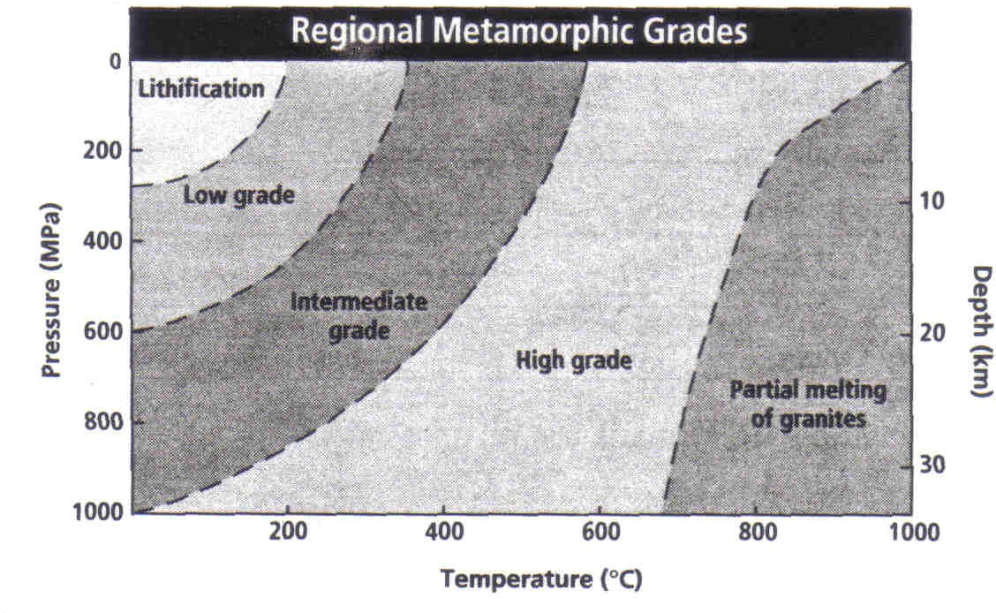

1. What grades of regional metamorphism are shown on the graph?
   1. Pressure
   2. Temperature
   3. Depth
   4. Texture
2. Which grades represent the highest- pressure conditions?
   1. Low
   2. Intermediate
   3. High
   4. BOTH Low & High
   5. BOTH Intermediate & High
3. Which grade generally occurs between O and 20 km below Earth's surface?
   1. Lithification
   2. Low Grade
   3. Intermediate Grade
   4. High Grade
   5. partial melting of Granites

## SECTION 6.3 Metamorphic Rocks, continued

*In your textbook, read about causes and types of metamorphism. Circle the letter of the choice that best completes the statement,*

1. The pressure required for metamorphism can be generated by
   1. pressure from the weight of overlying rock.
   2. heat from magma bodies in contact with surrounding rock
   3. cementation and lithification,
   4. hydrothermal solutions,
2. A regional metamorphic belt is divided into zones based upon
   1. the number of volcanoes in the area
   2. types of fossils found in the rocks.
   3. mineral groups found in the rocks.
   4. current underground temperatures
3. Contact metamorphism occurs under conditions of
   1. high temperature and high pressure,
   2. high temperature and moderate-to-low pressure.
   3. low temperature and very high pressure,
   4. low temperature and moderate-to-low pressure.
4. Minerals that crystallize at higher temperatures as a result of contact metamorphism tend to be found near. ·
   1. coal deposits
   2. bodies of water
   3. coral reefs
   4. igneous intrusions
5. The type of metamorphism that occurs when very hot water reacts with and alters the mineralogy of rock is
   1. Contact
   2. Regional
   3. Hydrothermal
   4. Local
6. Metamorphic rocks in which the long axes of their minerals are perpendicular to the pressure that altered them are described as
   1. marble-like
   2. quartzite-like
   3. foliated
   4. nonfoliated
7. Metamorphic rocks that lack mineral grains with long axes oriented in one direction are described as
   1. marble-like
   2. quartzite-like
   3. foliated
   4. nonfoliated