Tornado formation

***Use with Chapter 13***

***Section 13.2***



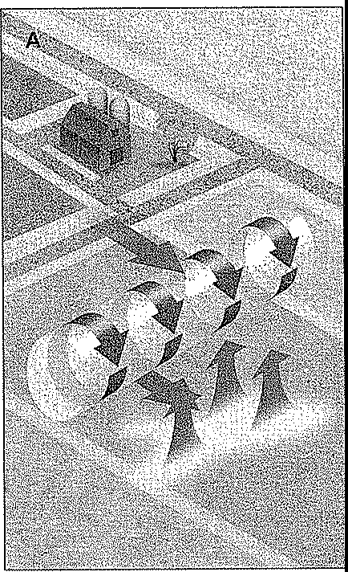

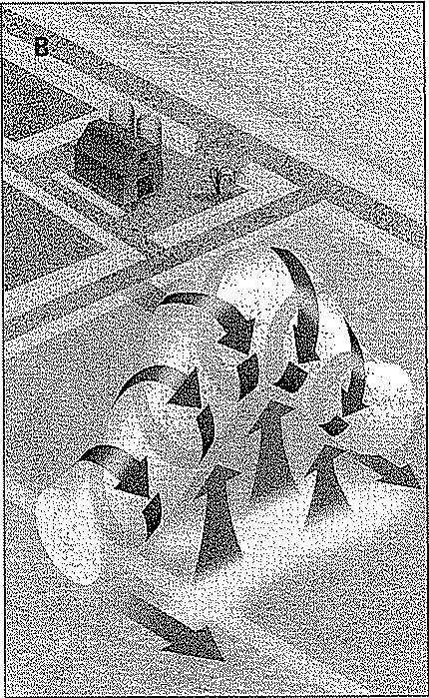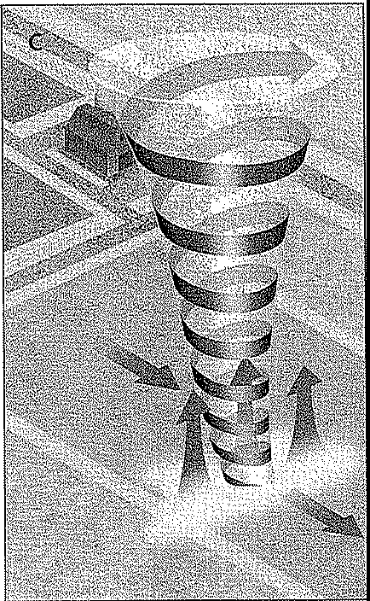

Teaching Transparency Transparency Master 35 *Earth Science: Geology, the Environment, and the Universe* 61

**Name Class Date**

Tornado Formation

1. Tornadoes are often associated with very severe thunderstorms. What are these violent thunderstorms called?

***Section 13.2***

1. In diagram A, what causes air to rotate horizontally near Earth's surface? What is this phenomenon called?

t

1. Describe what is occurring in diagram B.
2. Is the center of the column of twisting air an area of high pressure or low pressure? Explain your answer.
3. What characteristic of a supercell would contribute to tornado formation?
4. Why can we see the air in a tornado?
5. How are the strong winds associated with the tornado in diagram C produced?

/l

**62 Transparency Worksheet 35 *Earth Science: Geology, the Environment, and the Universe* Teaching Transparency**