Composition of the Atmosphere: A Graphic Model

BACKGROUND:
The Earth's atmosphere is made up of a mixture of gases, liquids, and solids. However, the largest part, by far, consists of those substances that are usually found as gases. One exception, of course, is water. Water is nearly always present in the atmosphere as a liquid, solid, or gas. When it exists as a vapor, the amount of water in the "air" varies considerably from place to place and time to time. Variation may be as much as 3 percent. Most of the gases that make up the rest of the atmosphere are found in amounts nearly unchanging in any particular location or at any given height above sea level.

PROCEDURES:
In this activity you will construct a series of bar graphs that illustrate the relative amounts of those gases that make up more than 99 percent of the nonchanging components of the Earth's atmosphere.
DATA TABLE
Examine the Data Table from the American Meteorological Society. This
table lists by volume, the percentage
amounts of the four gases that make up
most of the Earth's atmosphere
Gases | Volume of Percentage
Argon | 0.93
Carbon Dioxide | 0.03
Nitrogen | 78.08
Oxygen | 20.95
Total = 99.99

Using the information provided in the Data Table and the graph paper included with this activity (see other side), construct a graph that consists of four separate bar graphs, one graph for each of the atmospheric components listed. You may color in each of the graphs using the colors of your choice. Label each column and indicate the percentage of gas in each column.
After completing the four bar graphs, answer the following questions.

- Which is the most abundant gas found in the Earth's atmosphere?

- What is its percentage? ____________%

- What is the total percentage of the gases listed? HINT: see Total%

- List in order of abundance from most to least, the four major components of the Earth's atmosphere.

Nitrogen
______________
_____________
Carbon Dioxide

- What is the probable reason for the fact that water vapor was not included in the Data Table of the major atmospheric components, even though it is often present in amounts far greater than either argon or carbon dioxide?
  - The amount of water vapor in the Earth’s atmosphere varies by up to ___________%

- What percentage of the volume of the Earth's atmosphere is not accounted for in the data provided?
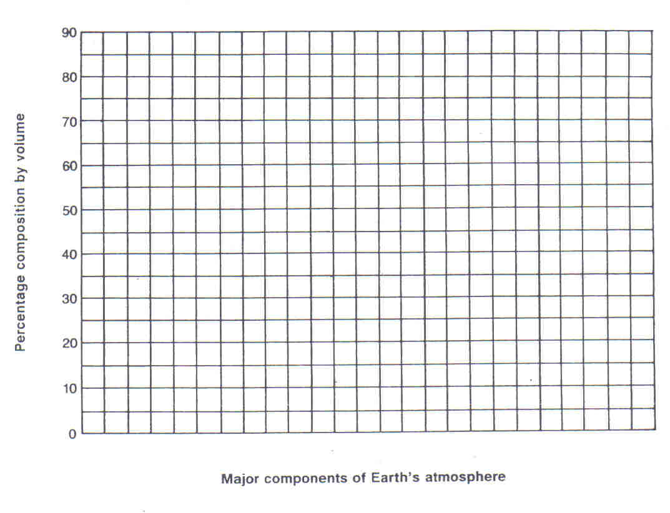
  - Total = 99.99% → 100% - 99.99%= _____________
85

75

65

55

45

35

25

15

5

N₂ O₂ Argon CO₂

